**Assignment -1**

**Python Programming**

|  |  |
| --- | --- |
| Assignment Date | 19 September 2022 |
| Student Name | Gokul Prasad E |
| Student Roll Number | 311019205014 |
| Maximum Marks | 2 Marks |

**Question-1:**

Create registration page in html with username, email and phone number and by u sing POST method

display it in next html page.

**Question-2:**

. Develop a flask program which should contain at least 5 packages used from pypi.org

Note:- Following application contains (Flask , render_template ,url_for, redirect, request) So both Questions have same Answers

**Source code :**

App.py

from flask import Flask, request, render_template, url_for,redirect

app = Flask(__name__)

@app.route('/success/<name>')

def success(name):

return 'welcome %s' %name

@app.route('/login', methods =['GET', 'POST'])

def login():

if request.method=="POST":

first_name = request.form.get("username")

email_id = request.form.get("email")

phone_num = request.form.get("number")

return "Your name is" +first_name + "Your email is" +email_id + "Your Phone number is"

+phone_num

return redirect(url_for('success',name = first_name))

if __name__=='__main__':

app.run(debug=True)

**index.html**

<head>

<meta charset="UTF-8" />

<title>Register</title>

<link>

<meta charset="UTF-8" />

title>

<link

/>

</head>

<nav class="navbar navbar-expand-lg navbar-light bg-light">

<a class="navbar-brand" href="#">Flask</a>

<button

class="navbar-toggler"

type="button"

data-toggle="collapse"

data-target="#navbarNavAltMarkup"

aria-controls="navbarNavAltMarkup"

aria-expanded="false"

aria-label="Toggle navigation"

<span class="navbar-toggler-icon"></span>

</button>

label for="exampleInputUserName">UserName</label>

<input

type="email"

class="form-control"

id="exampleInputEmail1"

aria-describedby="emailHelp"

placeholder="Enter email"

name="email"

/>

</div>

<label for="exampleInputPassword1">Password</label>

<input

type="password"

class="form-control"

id="exampleInputPassword1"

placeholder="Password"

name="password"

/>

</div>

<label for="exampleInputPhoneNumber">Phone Number</label>

<input

type="number"

class="form-control"

id="exampleInputPhoneNumber"

placeholder="Phone Number"

name="number"

/>

</div>

<div class="form-check">

<input type="checkbox" class="form-check-input" id="exampleCheck1" />

</div>

</form>

</body>

</html>

Output

Index Page :

**Output :**

**Index Page :**

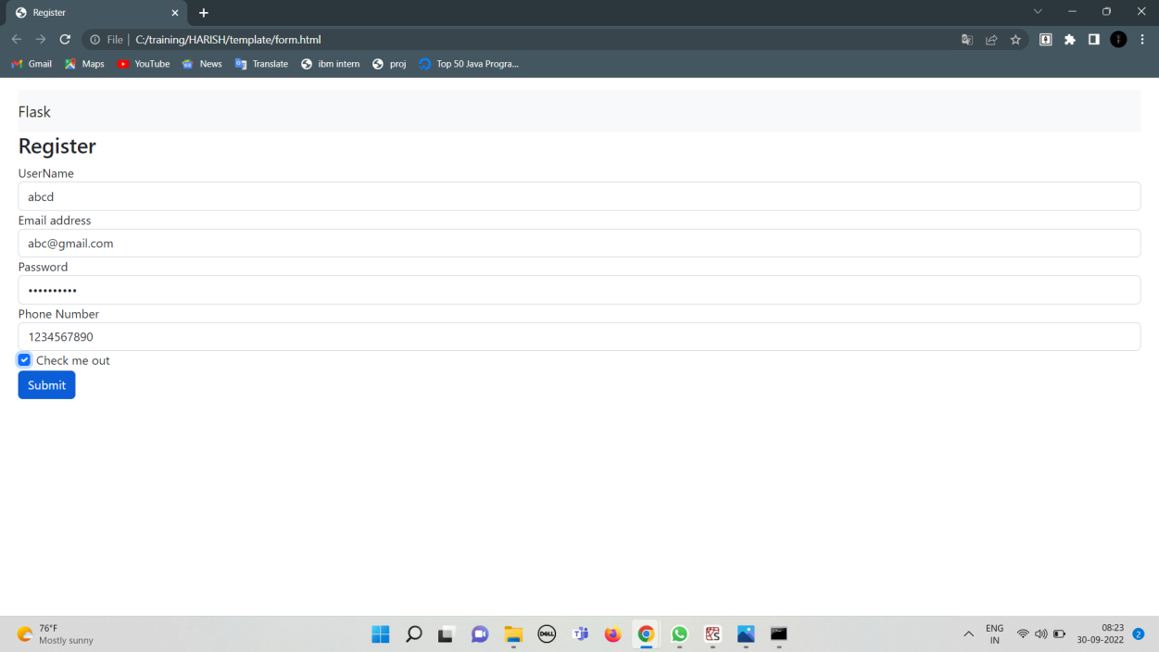

Login page successful

